PROJECT TOPIC: GESTURE CONTROLLED MEDIA PLAYER

Group No.:27

Project Group Members:
- Shivam Yadav (C-48 / 2384200197) 2. Keshav Prajapati (C-28 / 2384200086)
3. Arvind Arya (C-09 / 2384200035) 4. Ankit Gola (C-06 / 2384200024)
5. Kushal Dhangar (B-65 / 2384200098)

Project Supervisor: Dr. Sachendra Singh Chauhan/Assistant Professor

About the Project:
A Gesture-Controlled Media Player uses motion-sensing technology to allow users to control media playback without touching physical buttons. It typically employs cameras or sensors like infrared or ultrasonic to track hand or body movements. These gestures can include swiping, pointing, or hand waving to play, pause, skip, or adjust volume. The system translates these movements into commands via software algorithms. Such a media player offers a more immersive and intuitive way to interact with entertainment devices, making it ideal for environments where hands-free control is preferred.
Key features include easy navigation, a sleek interface, and compatibility with various media formats. As gesture recognition improves, the accuracy and responsiveness of media control are becoming more refined. This approach minimizes the need for remote controls, touchscreens, or voice assistants.
This document outlines a project aimed at creating a system that allows users to control VLC Media Player through hand gestures. By leveraging computer vision techniques and libraries such as OpenCV, the system captures hand movements via a camera, processes these gestures, and translates them into specific commands for the media player. This innovative approach not only enhances user experience but also provides a touch-free interface, making media control more intuitive and efficient.

Motivation:
The motivation behind this project stems from the desire to make human-computer interaction more intuitive and seamless. Traditional input methods such as keyboards and mice can feel restrictive in certain scenarios, like when watching videos or using multimedia applications. Gesture control offers a more natural, hands-free way of interacting with media, providing convenience and accessibility, particularly for people with mobility limitations or in hands-busy situations like cooking or working out.

Innovation:
- The innovation in this project lies in the integration of hand gesture recognition technology with a widely used media player like VLC or other open-source media players.
- The system translates specific hand movements into corresponding commands, adding a modern, user-friendly layer to media control.
- This project also explores the use of affordable and accessible hardware, like a webcam or smartphone camera, for gesture recognition, making the solution easy to implement.

A Gantt chart for project involves outlining the major tasks, their durations, and the timeline of the project. Here’s how we can structure Gantt chart based on the project activities.

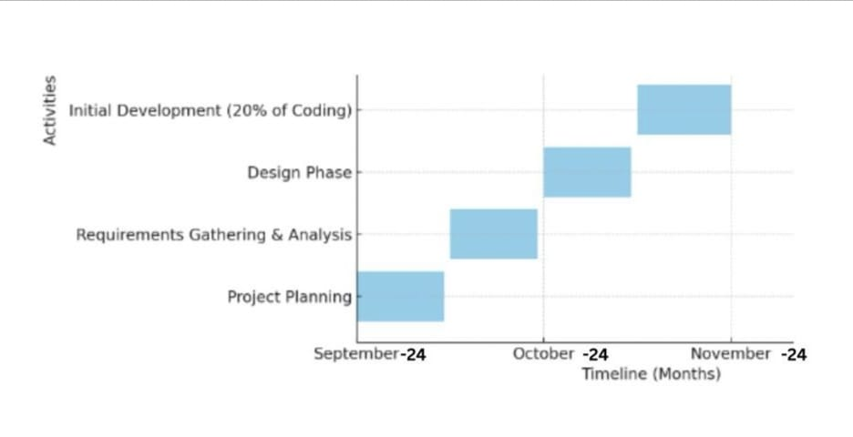

Tools required:
- Hardware Requirements:
- Computer: A standard laptop or desktop with at least 8 GB of RAM.
- Processor: Intel i5 or equivalent for smooth performance.
- Webcam or Camera: The camera should have a decent frame rate (at least 30 FPS) for smooth gesture recognition.
- VLC Media Player: The VLC Media Player software must be installed on your computer to allow control using hand gestures.
- Storage: 256 GB SSD and minimum 2GB (for program) for fast access to files and applications.

- Software Requirements:
- Gesture Recognition Model: custom-trained models using TensorFlow for recognizing specific hand gestures.
- Driver Software (for Camera): Camera drivers are installed and working properly on your system for capturing hand movements.
- IDE/Text Editor: Python-friendly integrated development environment or text editor for coding, like PyCharm.
- Programming Language: Python: Version 3.6 or above, as the primary programming language to implement the gesture recognition and VLC control functionality.
- Operating System: operating system capable of running Python, VLC Media Player, and the required libraries, windows.
- VLC Media Player: VLC version 3.0 or above for compatibility with external control through APIs or Python libraries.

- Python Libraries/Packages: NumPy, Python-VLC, PyAutoGUI or Keyboard, OpenCV and MediaPipe etc.

Signature of Project Supervisor: __________________

